**Tema 3**

Exercitiul 1

DECLARE

numar number(3):=100;

mesaj1 varchar2(255):='text 1';

mesaj2 varchar2(255):='text 2';

BEGIN

DECLARE

numar number(3):=1;

mesaj1 varchar2(255):='text 2';

mesaj2 varchar2(255):='text 3';

BEGIN

numar:=numar+1;

mesaj2:=mesaj2||' adaugat in sub-bloc';

dbms_output.put_line(numar);

dbms_output.put_line(mesaj1);

dbms_output.put_line(mesaj2);

END;

numar:=numar+1;

mesaj1:=mesaj1||' adaugat un blocul principal';

mesaj2:=mesaj2||' adaugat in blocul principal';

dbms_output.put_line(numar);

dbms_output.put_line(mesaj1);

dbms_output.put_line(mesaj2);

END;

/

a) Valoarea variabilei numar in subbloc este 2.

b) Valoarea variabilei mesaj1 in subbloc este "text 2".

c) Valoarea variabilei mesaj2 in subbloc este "text 3 adaugat in sub-bloc".

d) Valoarea variabilei numar in bloc este 101.

e) Valoarea variabilei mesaj1 in bloc este "text 1 adaugat un blocul principal".

f) Valoarea variabilei mesaj2 in bloc este "text 2 adaugat in blocul principal".

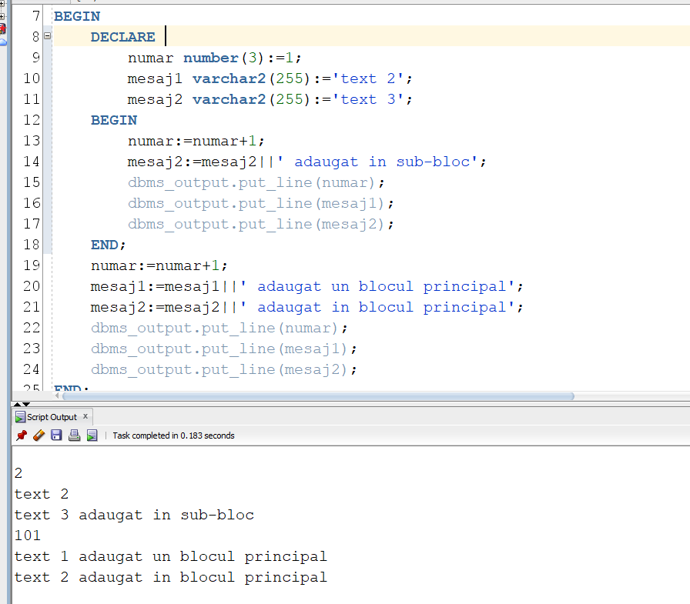

Exercitiul 2

a)

select dt, (

select count(*)

from rental

where to_char(book_date, 'dd') = to_char(dt, 'dd') and to_char(book_date, 'Mon') = 'Oct'

) as "Imprumuturi"

from (

select (last_day('1-Oct-22') - rownum + 1) dt

from dual

connect by rownum <= extract(day from last_day('1-Oct-22'))

)

order by dt;

b)

create table octombrie_pam(

id number,

data date

);

DECLARE

imprumuturi NUMBER := 0;

ultima_zi NUMBER := to_char(last_day('1-Oct-22'), 'dd');

BEGIN

FOR zi IN 1..ultima_zi LOOP

select count(*)

into imprumuturi

from rental

where to_char(book_date, 'dd') = zi and to_char(book_date, 'Mon') = 'Oct';

INSERT INTO octombrie_pam VALUES (imprumuturi, TO_DATE(zi ||'.10.2022', 'DD.MM.YYYY'));

END LOOP;

END;

/

Exercitiul 3

DECLARE

v_imprumuturi NUMBER;

v_nume VARCHAR2(25) := '&nume';

BEGIN

select count(distinct(r.title_id))

into v_imprumuturi

from rental r join member m on (r.member_id(+) = m.member_id)

where lower(last_name) = lower(v_nume) or lower(first_name) = lower(v_nume)

group by m.member_id;

dbms_output.put_line('Numarul de filme imprumutate de ' || v_nume || ' este '|| v_imprumuturi);

EXCEPTION

WHEN NO_DATA_FOUND THEN

dbms_output.put_line('Nu exista niciun membru cu numele dat!');

WHEN TOO_MANY_ROWS THEN

dbms_output.put_line('Exista mai multi membrii cu acelasi nume!');

END;

/

Exercitiul 4

select * from rental;

select * from member;

DECLARE

v_imprumuturi NUMBER;

v_titluri NUMBER;

v_proc NUMBER;

v_nume VARCHAR(101) := '&nume';

BEGIN

select count(*) into v_titluri

from title;

select count(distinct(r.title_id))

into v_imprumuturi

from rental r join member m on (r.member_id(+) = m.member_id)

where lower(last_name) = lower(v_nume) or lower(first_name) = lower(v_nume)

group by m.member_id;

v_proc := (v_imprumuturi/v_titluri)*100;

if v_proc > 75 then

dbms_output.put_line('Categoria 1');

elsif v_proc > 50 then

dbms_output.put_line('Categoria 2');

elsif v_proc > 25 then

dbms_output.put_line('Categoria 3');

else

dbms_output.put_line('Categoria 4');

end if;

EXCEPTION

WHEN NO_DATA_FOUND THEN

dbms_output.put_line('Nu exista niciun membru cu numele dat!');

WHEN TOO_MANY_ROWS THEN

dbms_output.put_line('Exista mai multi membrii cu acelasi nume!');

END;

/

EXERCITIUL 5

create table member_pam as select * from member;

alter table member_pam

add discount number;

set serveroutput on;

DECLARE

v_cod_membru member_pam.member_id%TYPE := &cod;

v_imprumuturi NUMBER;

v_titluri NUMBER;

v_proc NUMBER;

BEGIN

select count(*) into v_titluri

from title;

select count(distinct(r.title_id))

into v_imprumuturi

from rental r join member m on (r.member_id(+) = m.member_id)

where m.member_id = v_cod_membru

group by m.member_id

having m.member_id = v_cod_membru;

v_proc := (v_imprumuturi/v_titluri)*100;

if v_proc > 75 then

update member_pam

set discount = 10

where member_id = v_cod_membru;

commit;

dbms_output.put_line('Actualizare realizata');

elsif v_proc > 50 then

update member_pam

set discount = 5

where member_id = v_cod_membru;

commit;

dbms_output.put_line('Actualizare realizata');

elsif v_proc > 25 then

update member_pam

set discount = 3

where member_id = v_cod_membru;

commit;

dbms_output.put_line('Actualizare realizata');

else

update member_pam

set discount = 0

where member_id = v_cod_membru;

commit;

dbms_output.put_line('Actualizare realizata');

end if;

EXCEPTION

WHEN NO_DATA_FOUND THEN

DBMS_OUTPUT.PUT_LINE('Actualizare esuata, nu exista niciun angajat cu acest cod');

END;

/